CHAPTER 2
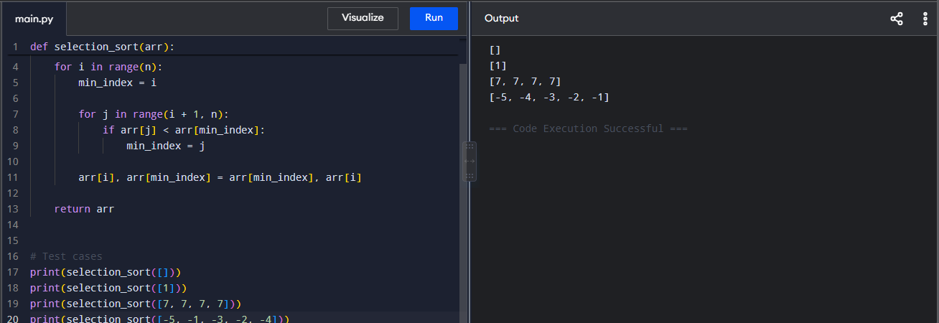
- Find Maximum and Minimum in an Array

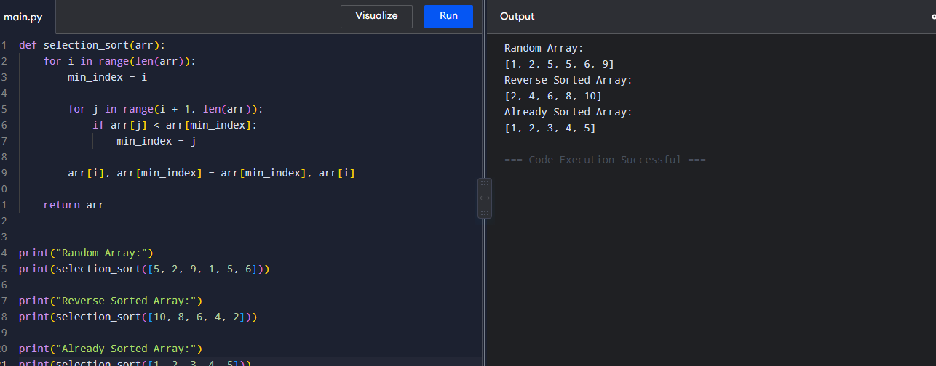
- Selection Sort

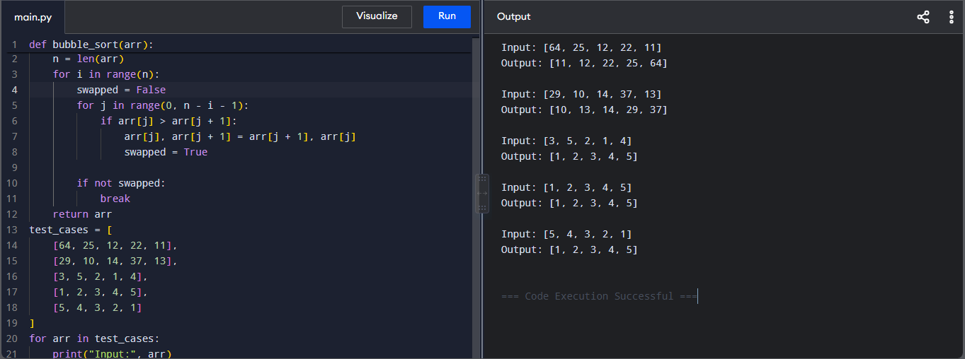
- Optimized Bubble Sort


- Insertion Sort with Duplicate Elements

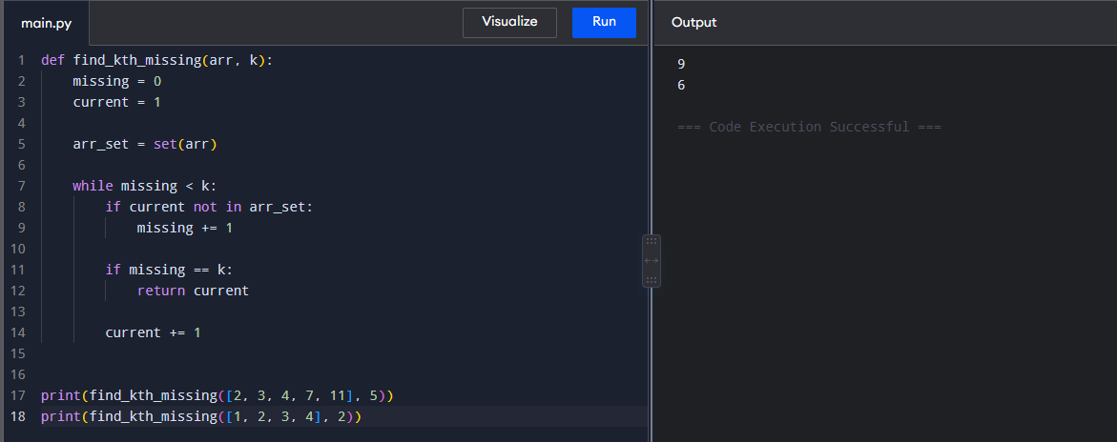
- Kth Missing Positive Number

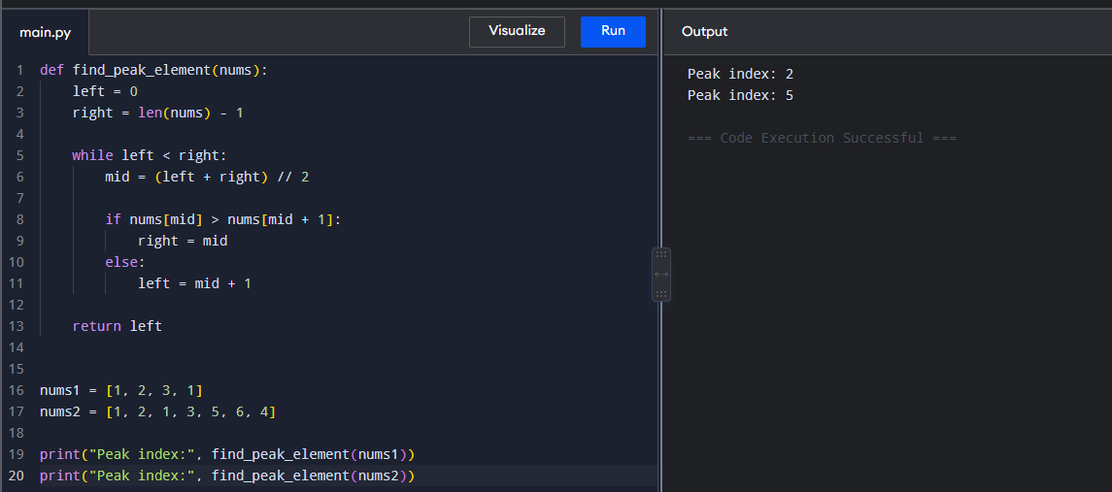
- Find Peak Element using Binary Search
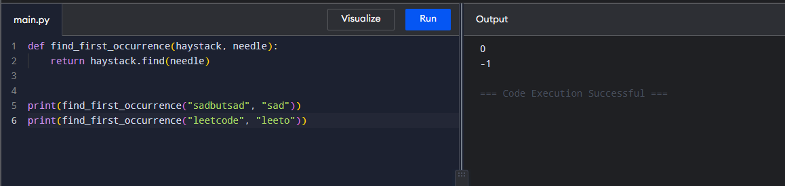
- Find First Occurrence of a String

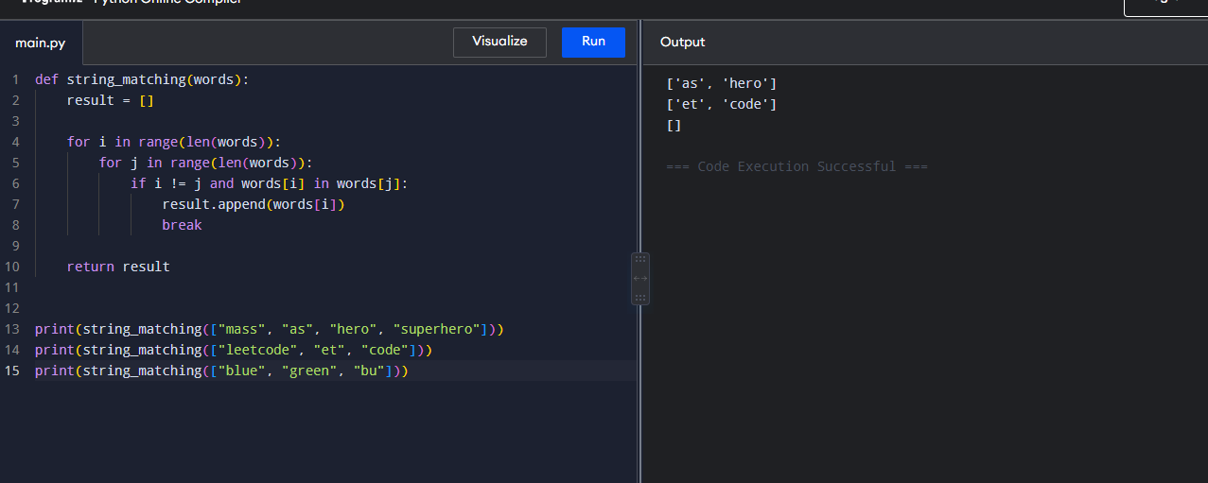
- Find Strings that are Substrings of Another Word

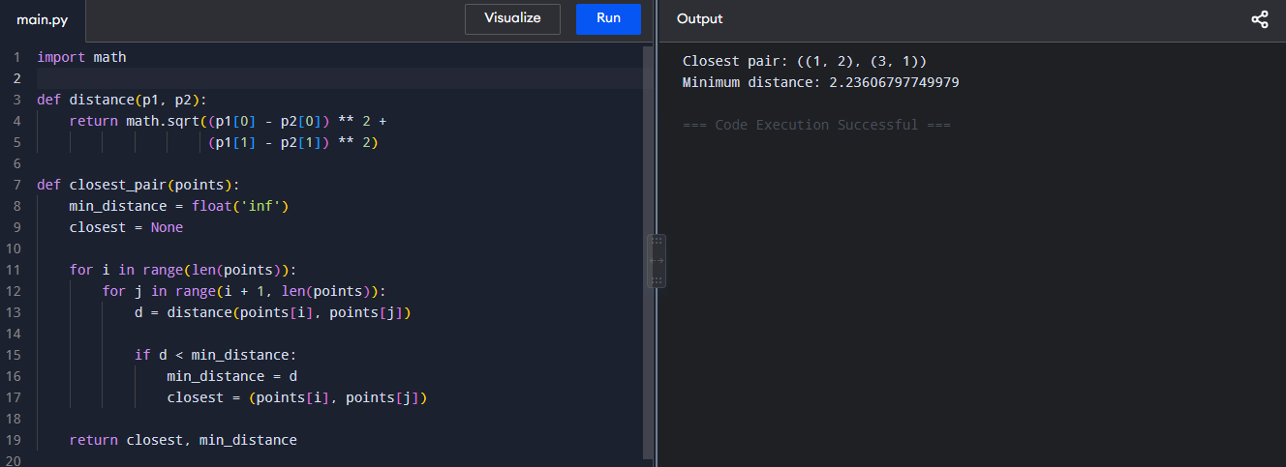
- Closest Pair of Points using Brute Force

- Convex Hull using Brute Force
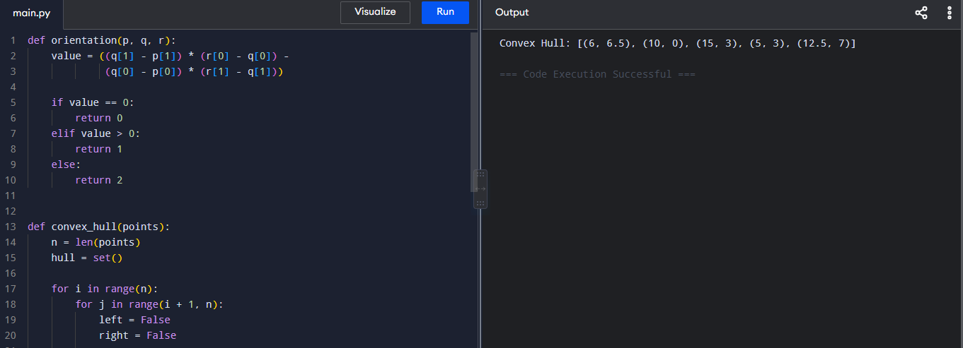
- Convex Hull of 2D Points using Brute Force
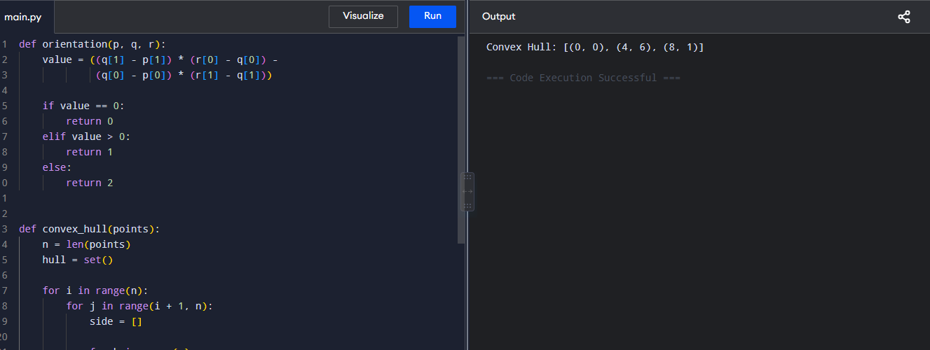
- Travelling Salesman Problem using Exhaustive Search
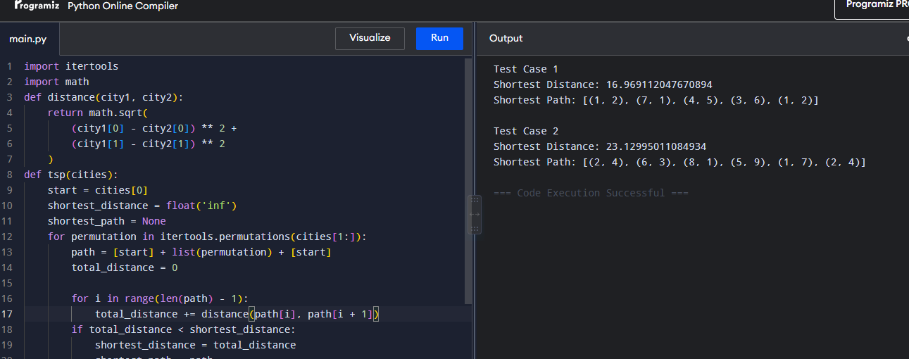

- Assignment Problem using Exhaustive Search
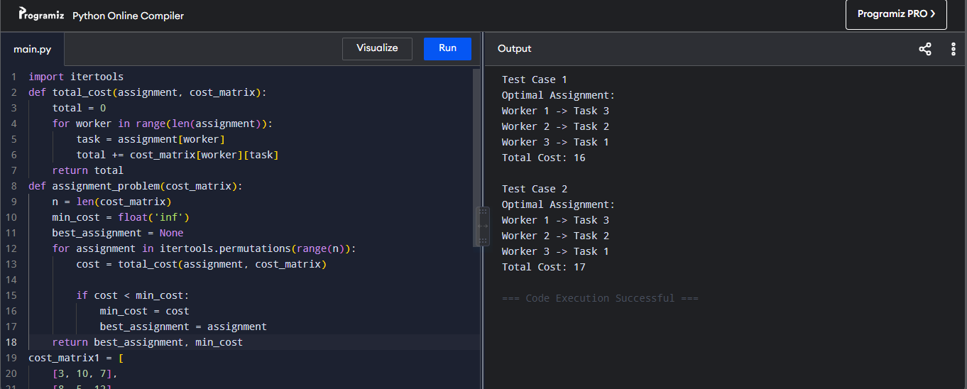

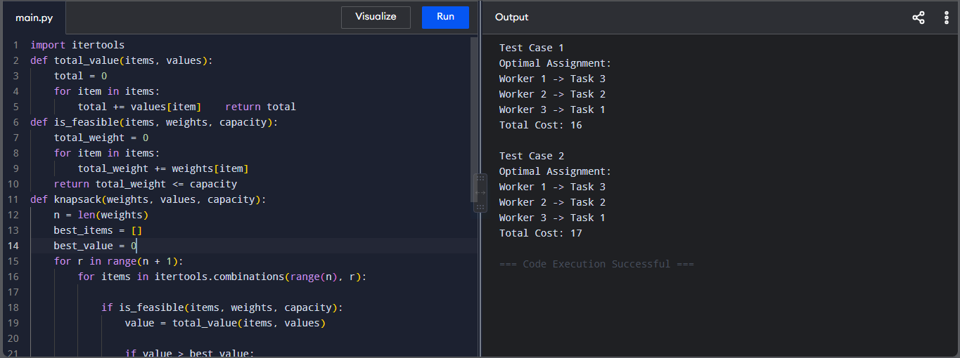
- 0/1 Knapsack Problem using Exhaustive Search

